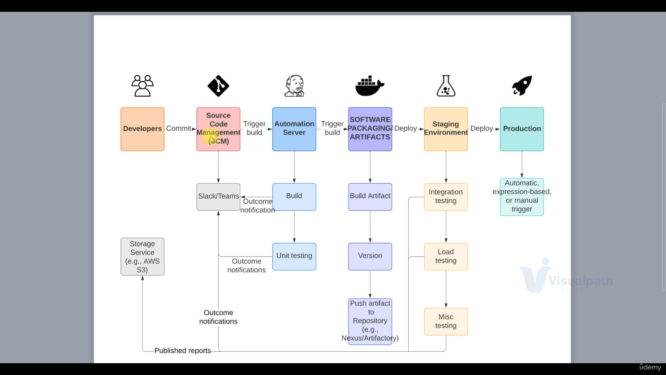

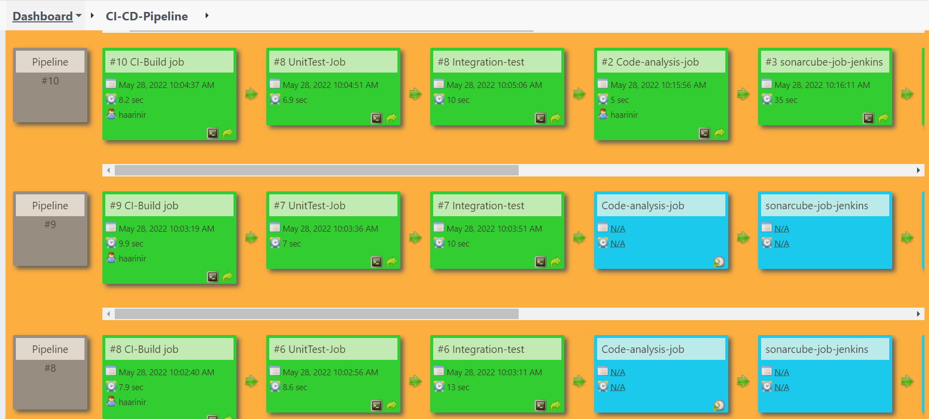

Servers involved:

Step1: Build Job

Fetch the code from git hub and generate artifact

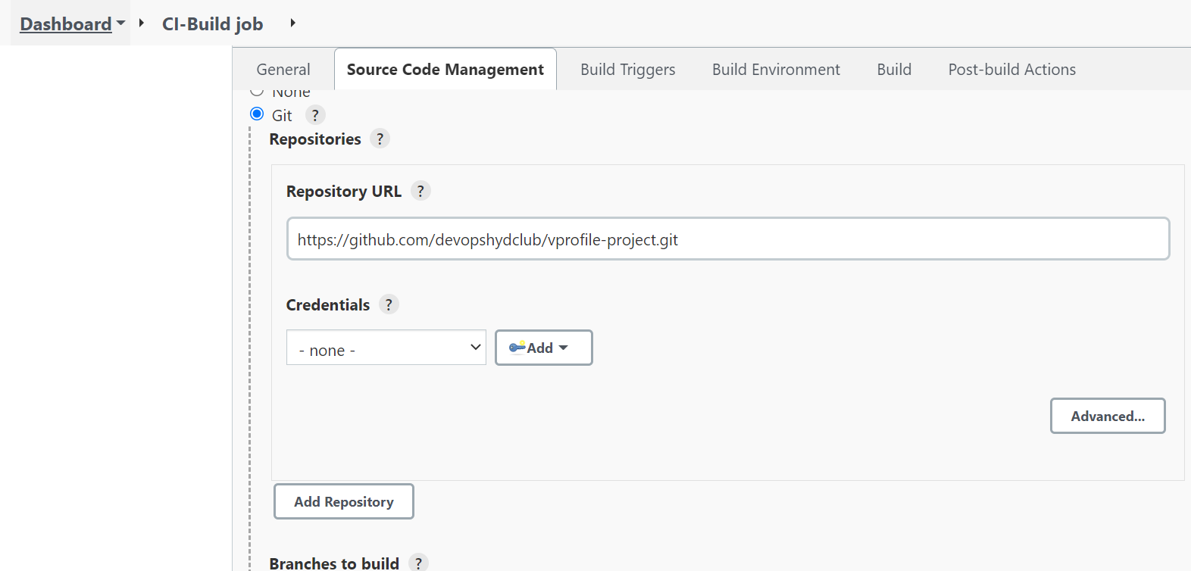

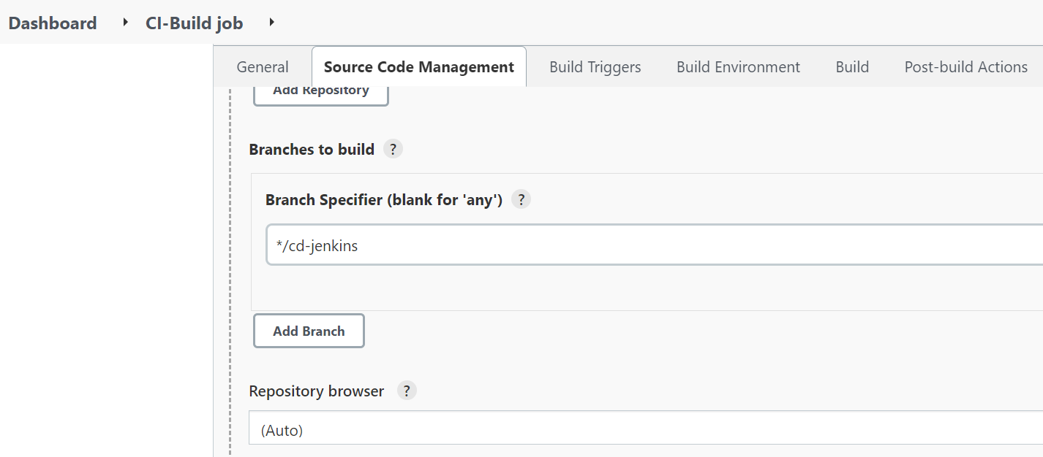

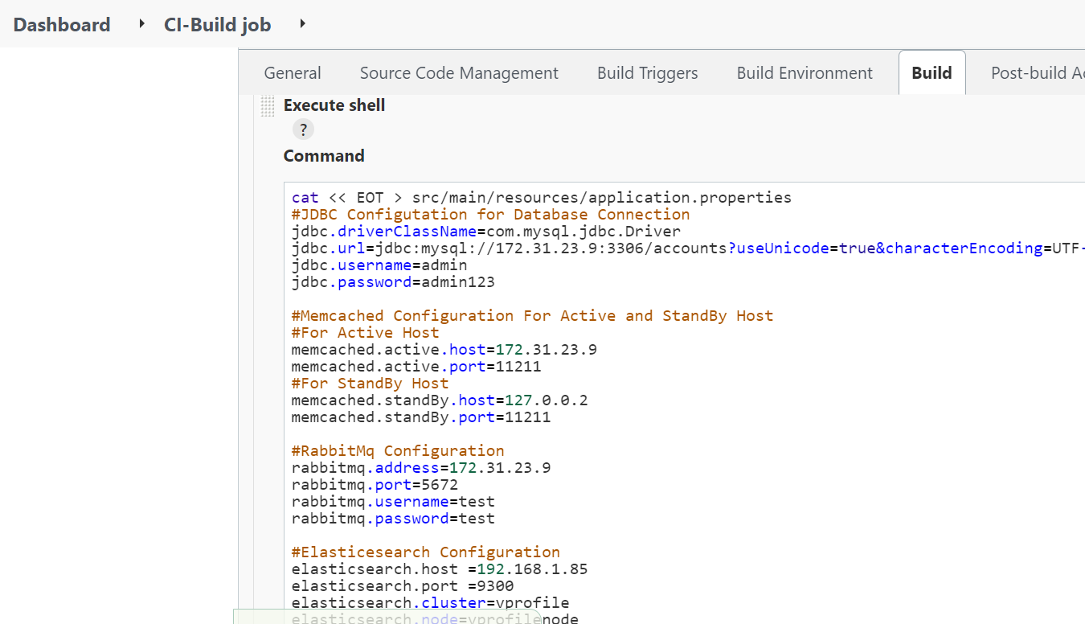

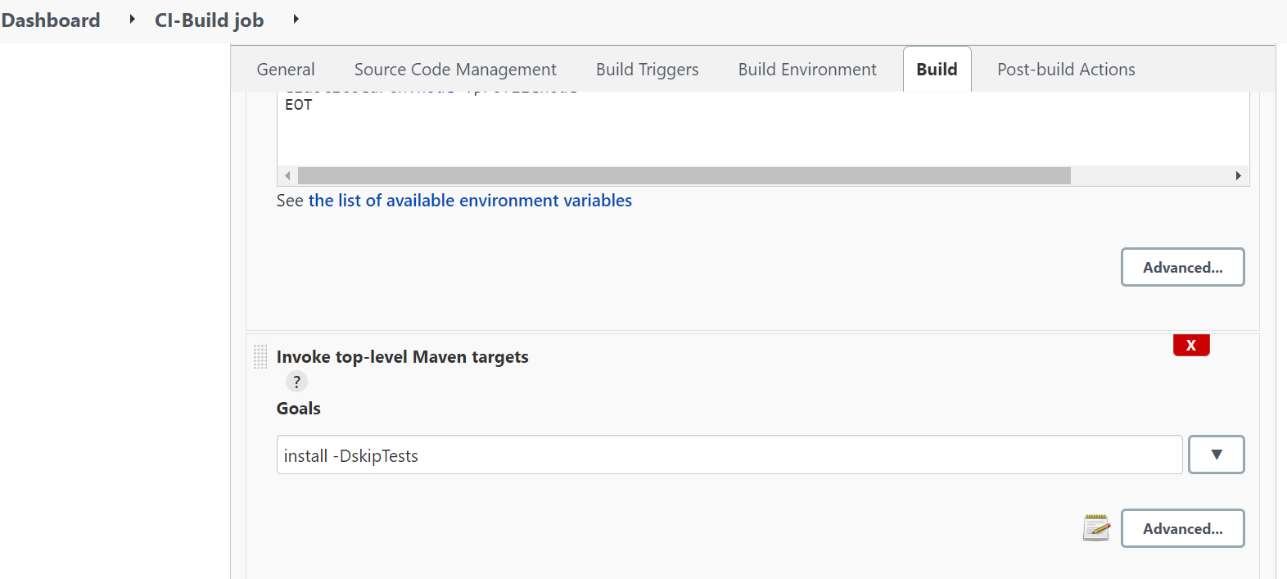

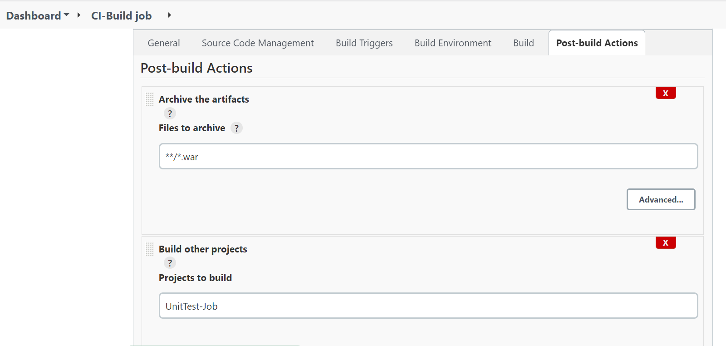

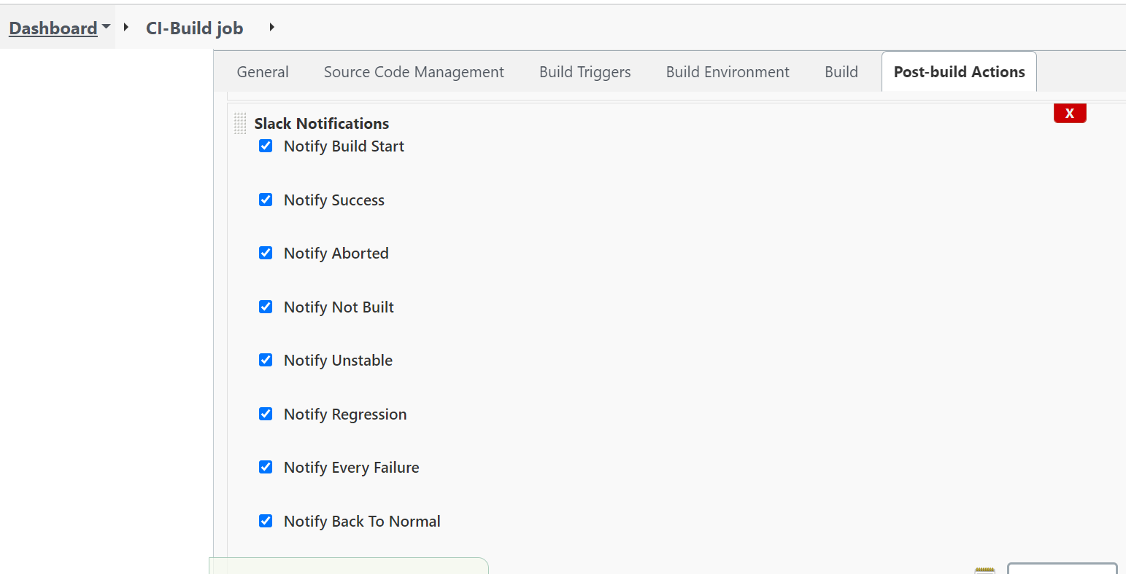

Specify workspace, channel, workspace(invite a bot to the created channel)

Step2: Unit test job

perform unit testing using maven

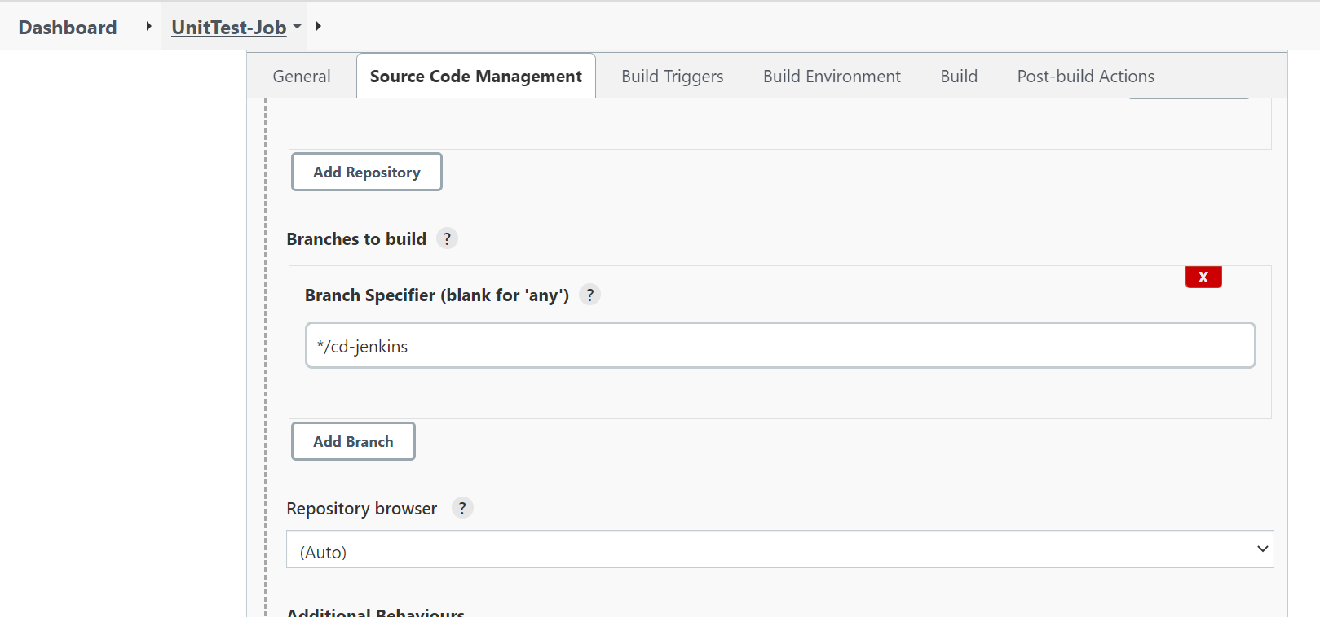

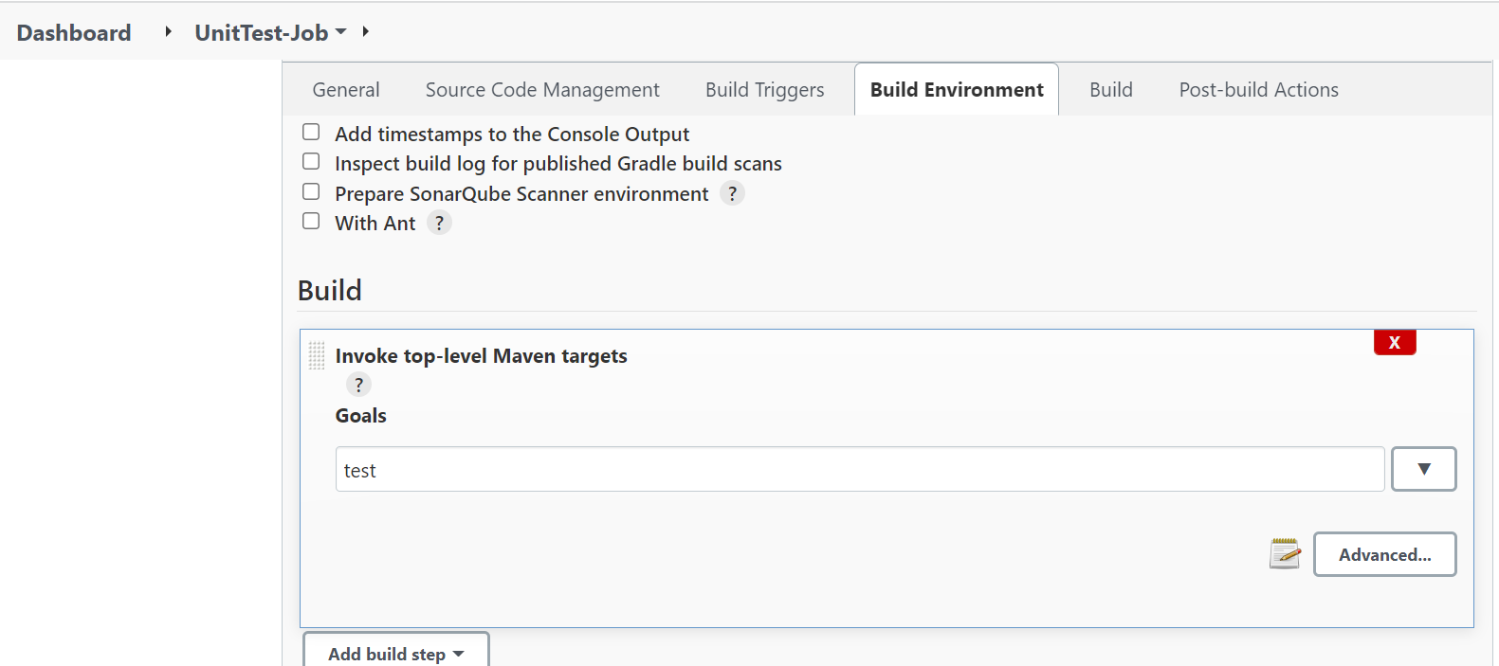

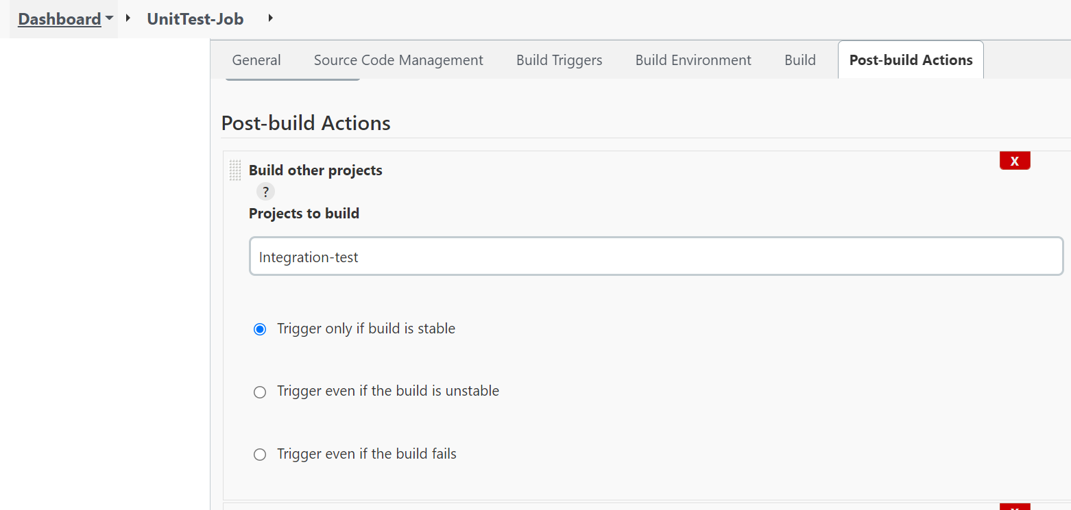

Step 3: Perform integrated testing with maven

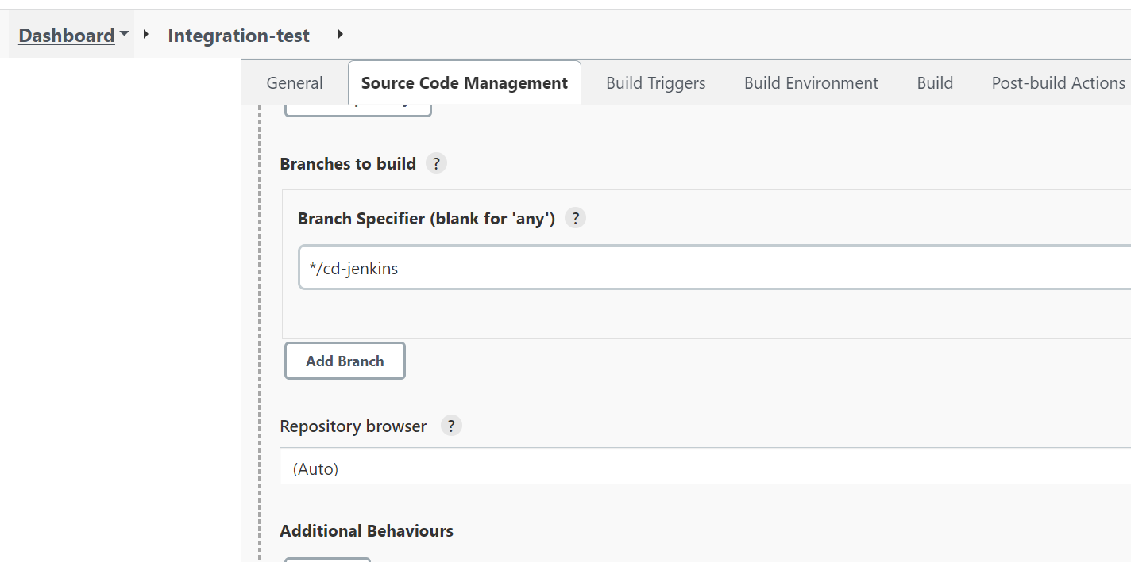

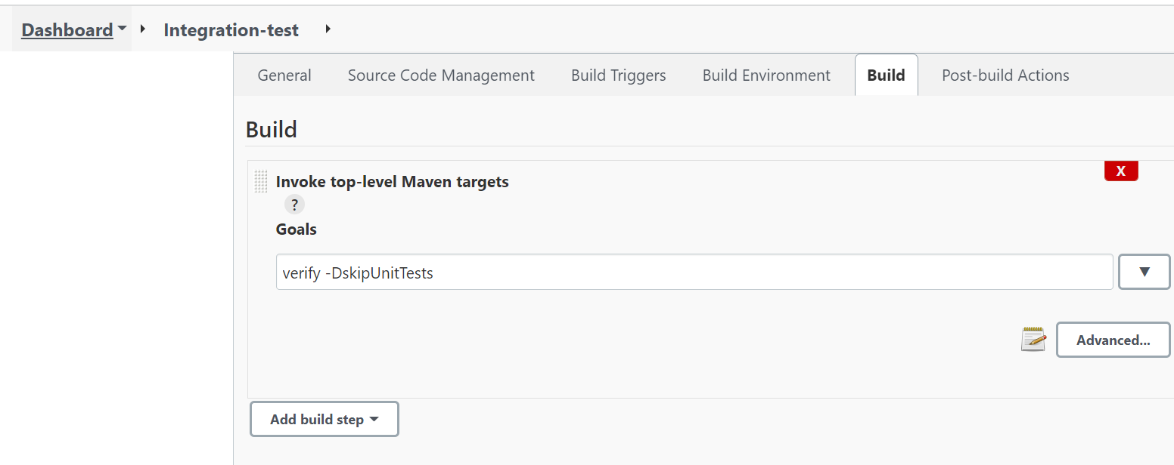

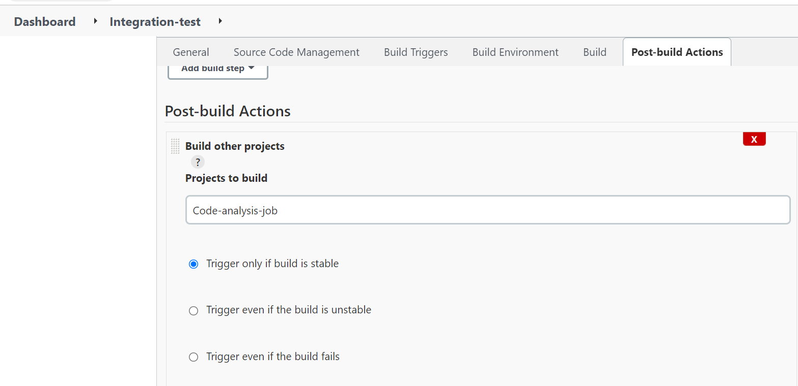

Step 4: Perform code analysis using checkstyle

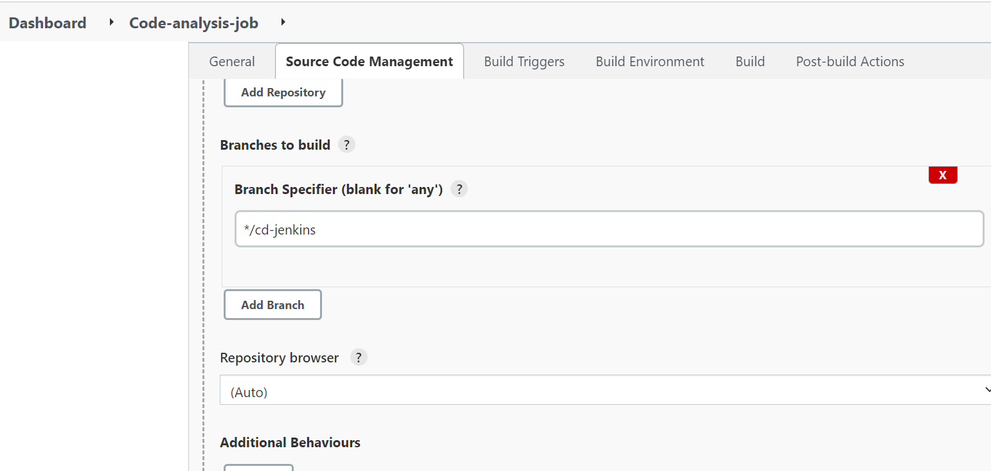

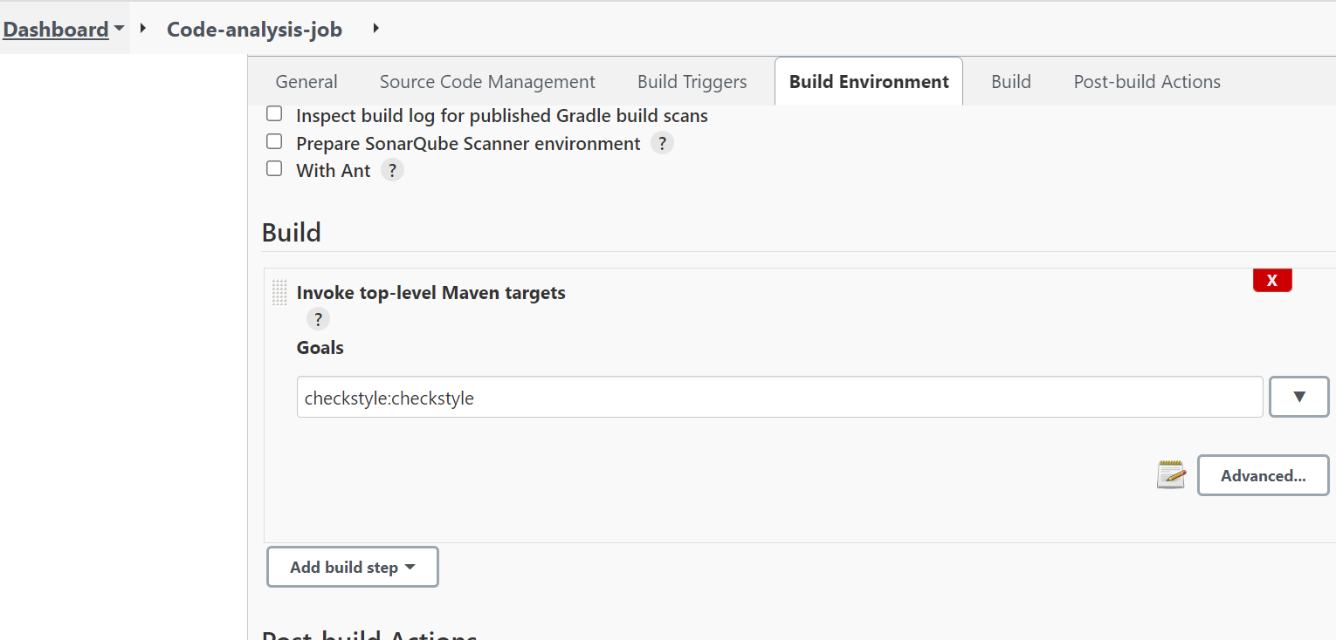

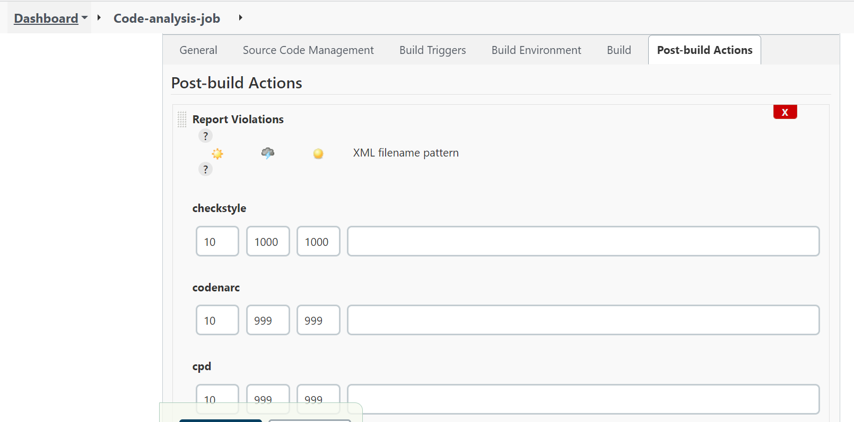

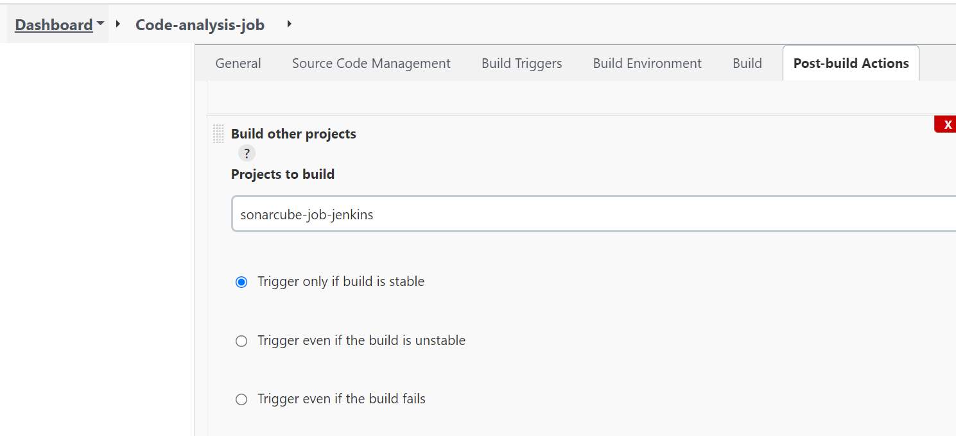

Step 5: Perform code analysis and quality gate checking with sonarqube

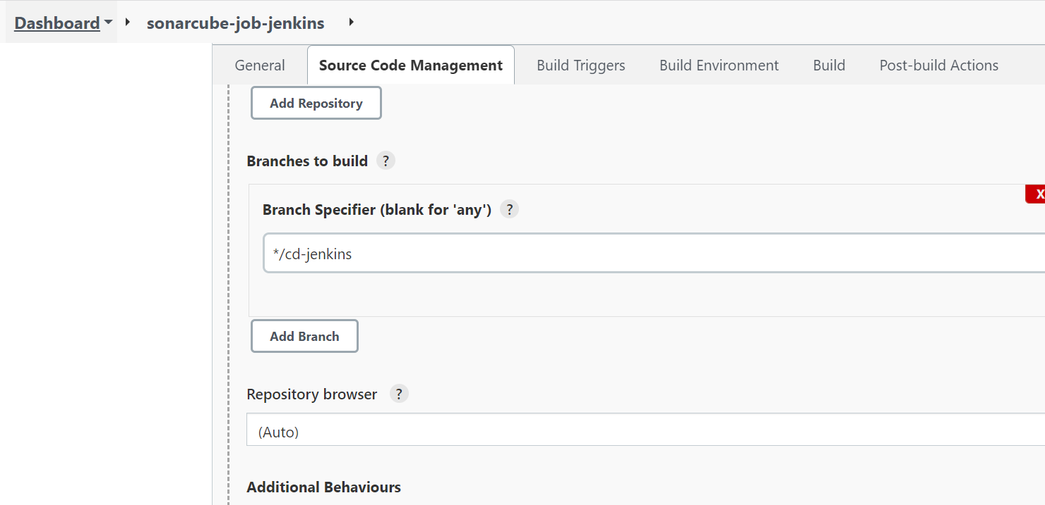

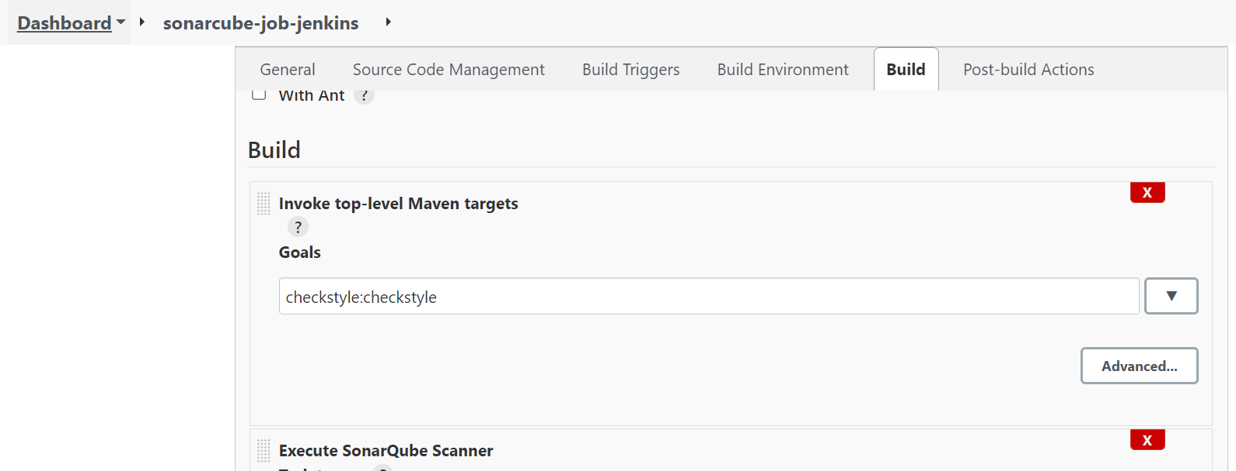

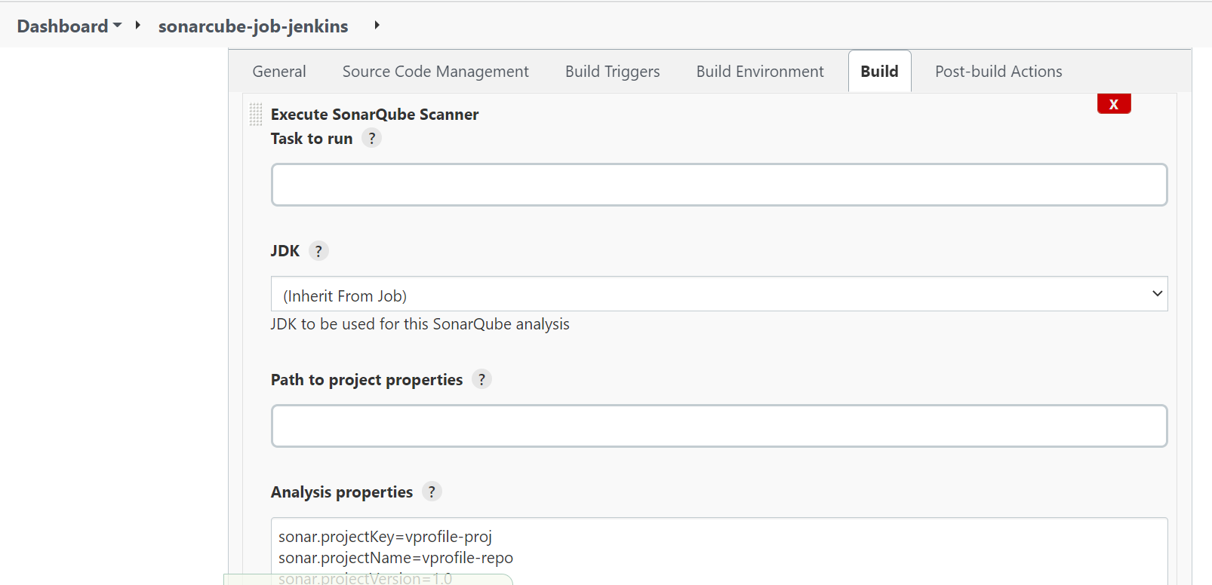

(In configure system -> install sonarcube installer,download quality gates and sonarcube plugins

sonar.projectKey=vprofile-proj

sonar.projectName=vprofile-repo

sonar.projectVersion=1.0

sonar.sources=src/

sonar.java.binaries=target/test-classes/com/visualpathit/account/controllerTest/

sonar.junit.reportsPath=target/surefire-reports/

sonar.jacoco.reportsPath=target/jacoco.exec

sonar.java.checkstyle.reportPaths=target/checkstyle-result.xml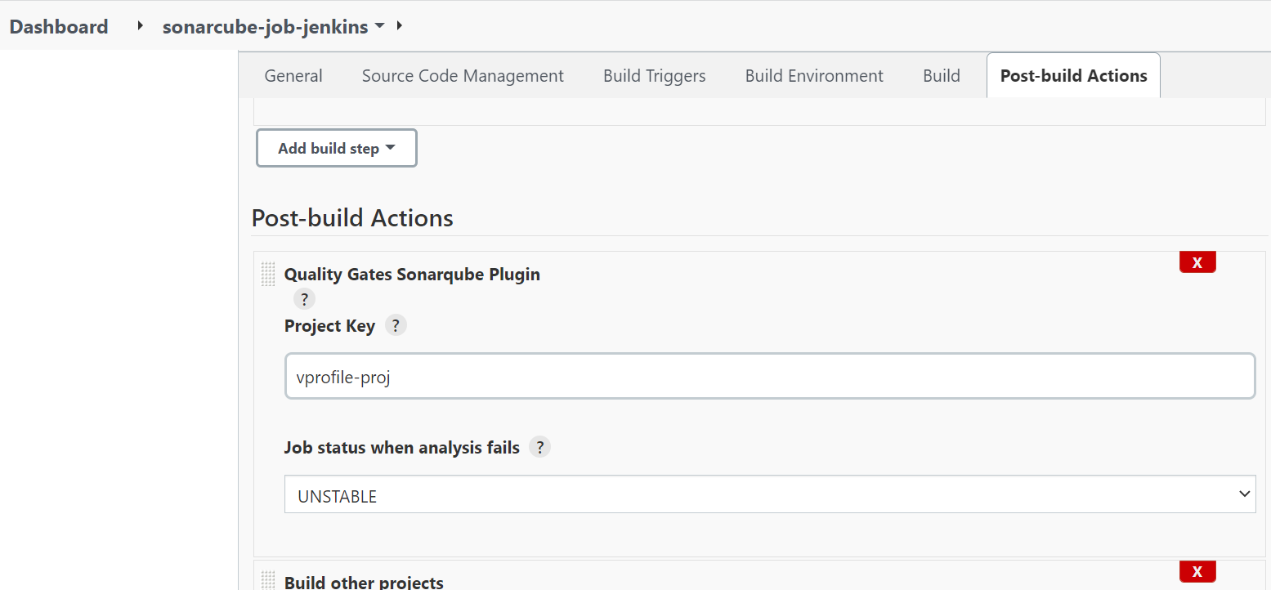

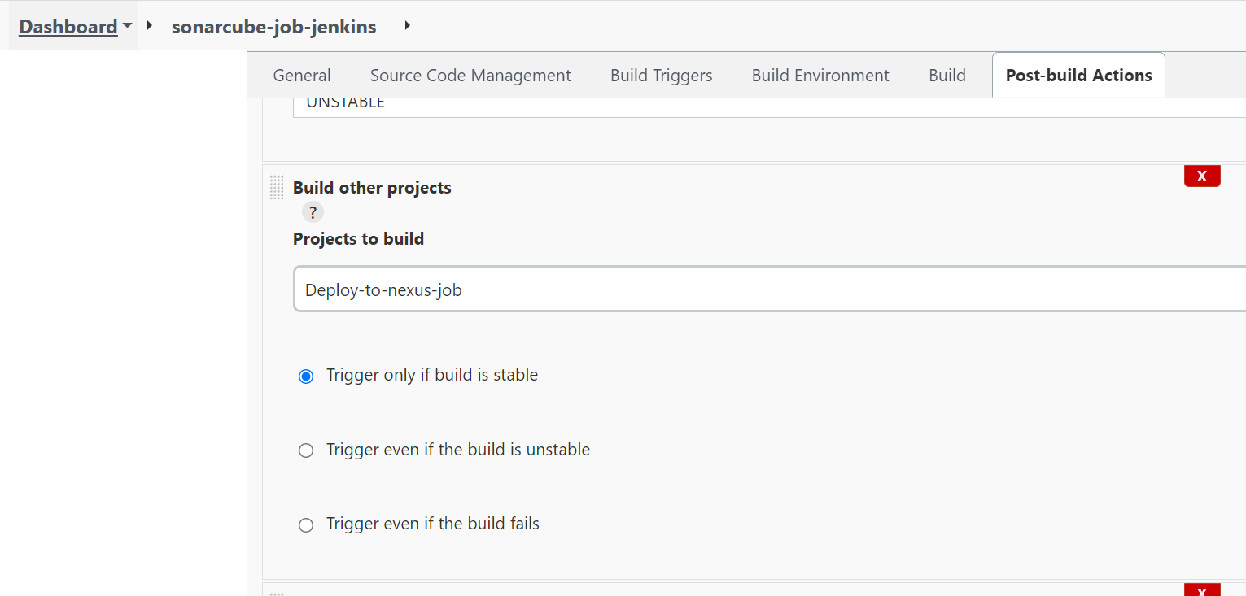

Sonarqube global jenkins Configurations:

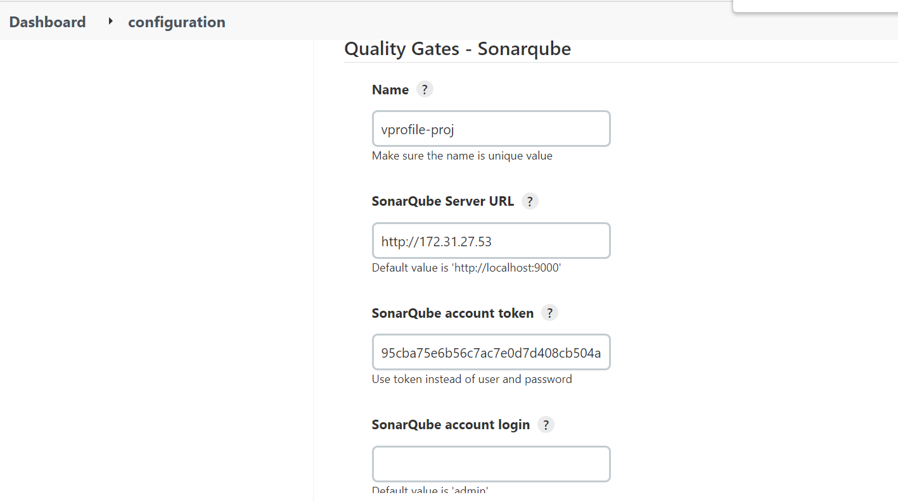

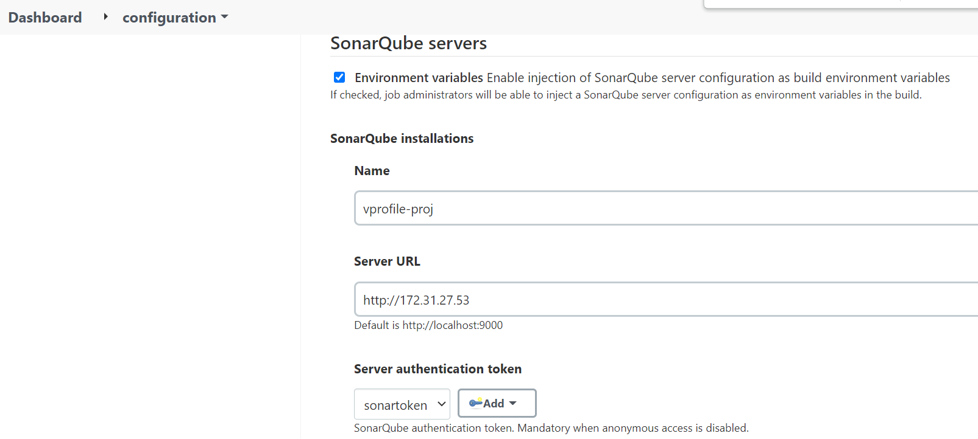

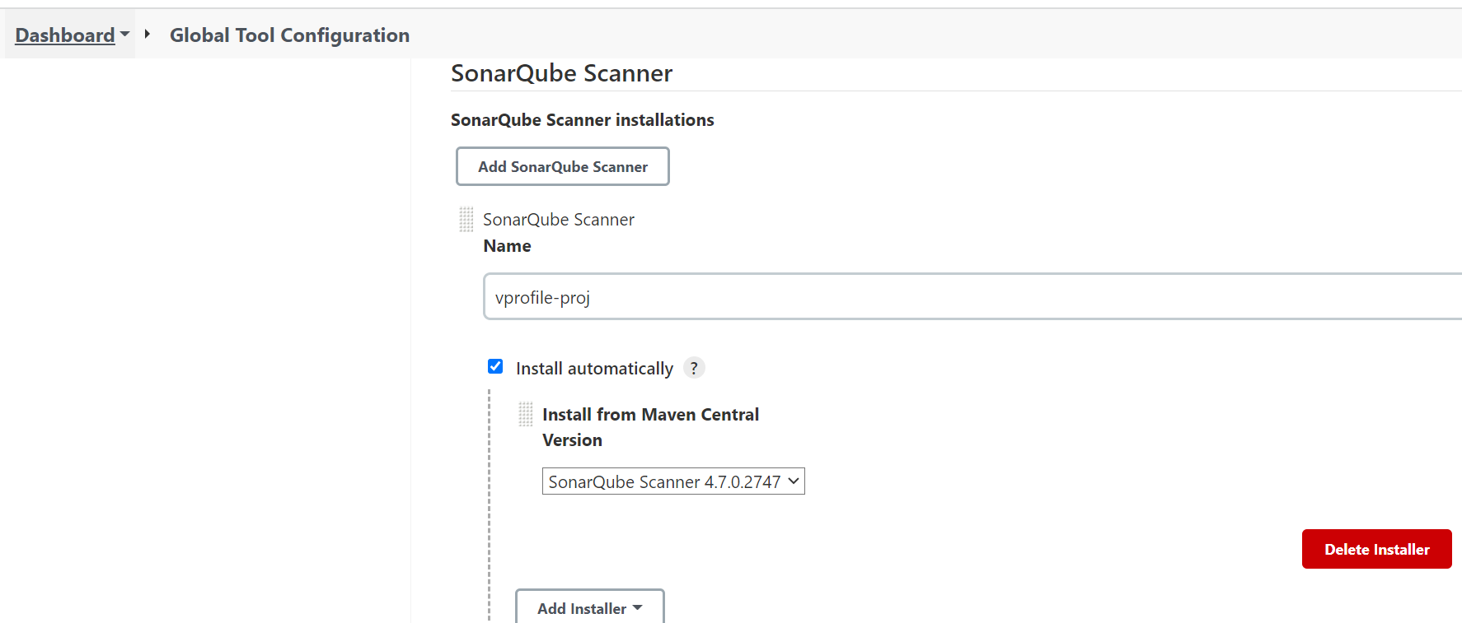

Step 6: Upload artifact to nexus repository

Step 7: Deploying artifact to staging environment(tomcat)

Step 8: Test URL job – to check if the URL is up and running

Step 9: Configure a windows slave node and run selenium script to check if web application can be logged in

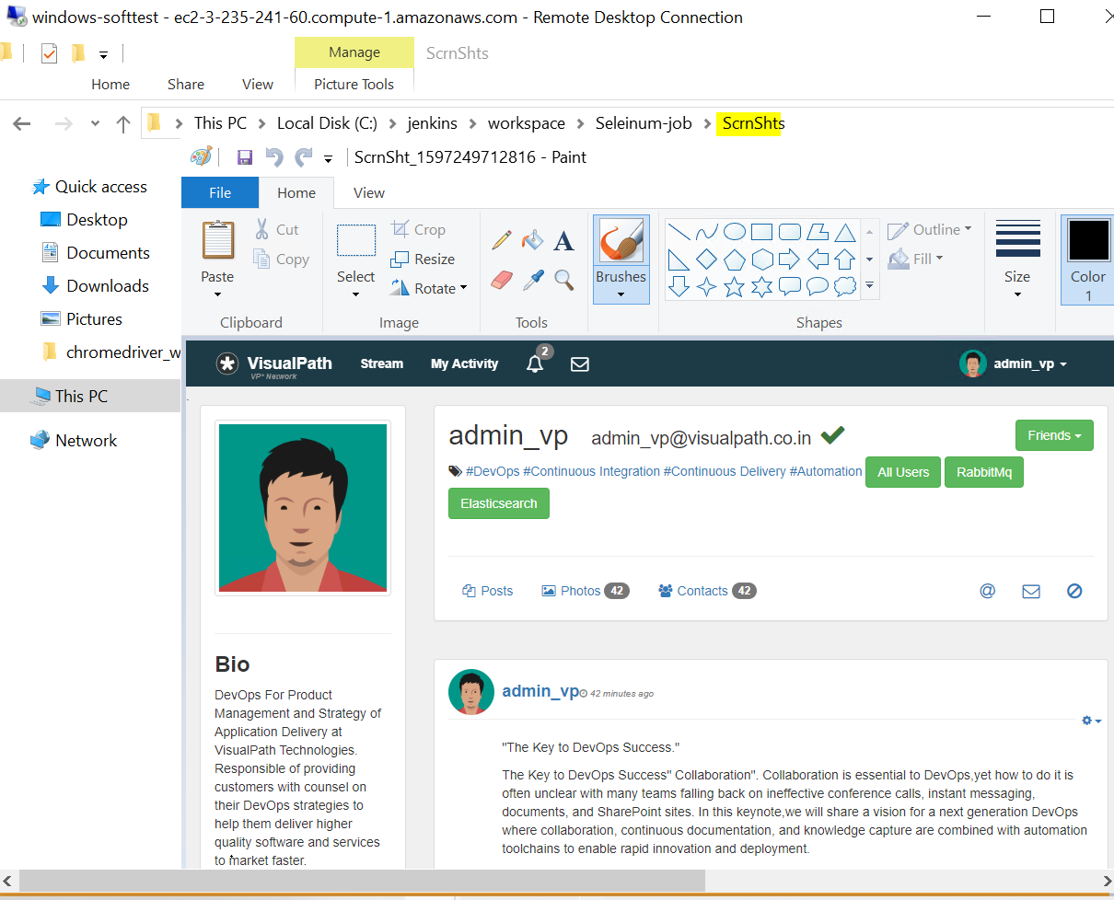

Step 9: Finally when all steps are successful, deploy the artifact to the production environment

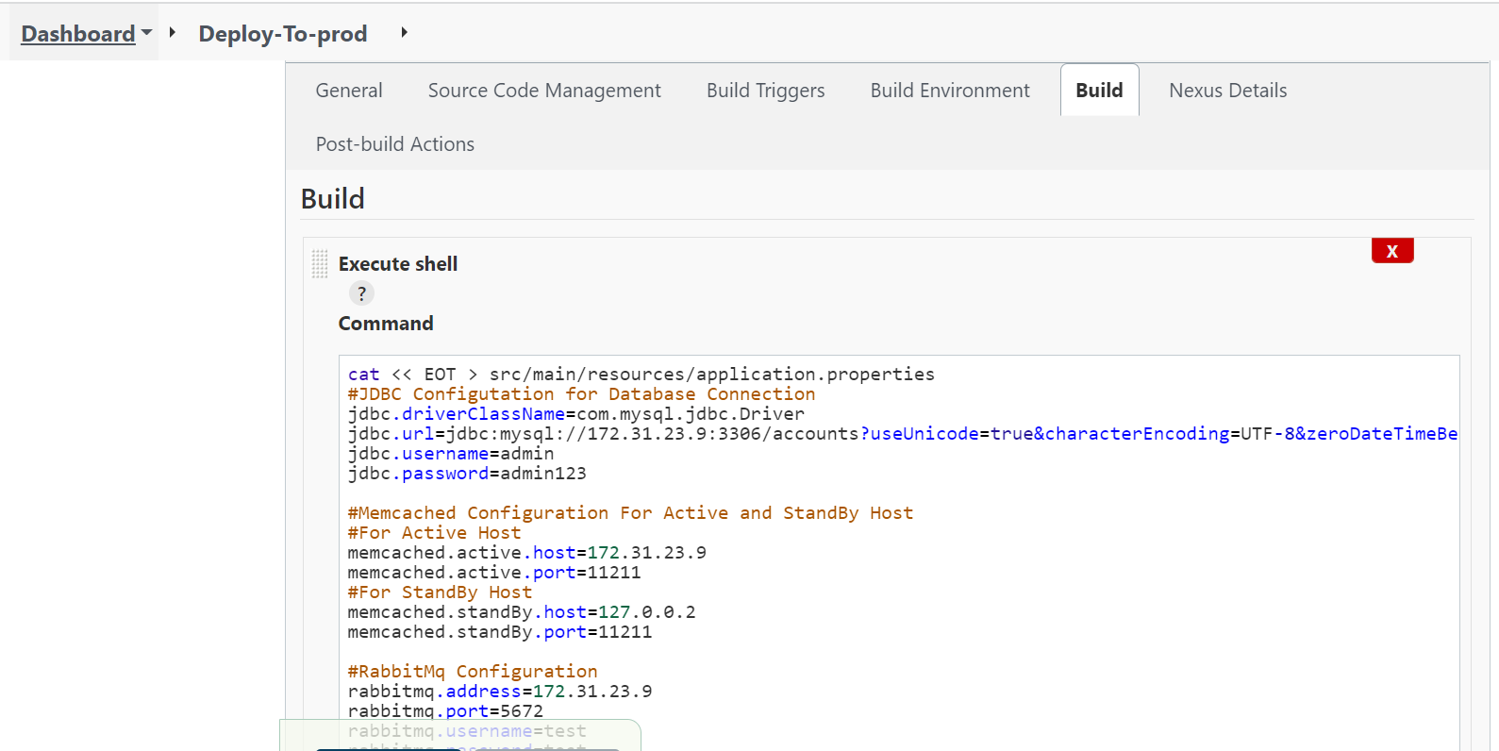

Overall integration of all jobs with slack

